Computer Vision Lab Record (Experiments 1–5)

Experiment 1: Read an Image and Convert it to Grayscale

Aim
To read an image and convert it into a grayscale image using OpenCV.

Procedure
- Import OpenCV.
- Read the input image.
- Convert it to grayscale.
- Display the original and grayscale images.
- Close all windows.

Algorithm
- Start
- Import required libraries
- Read the image
- Perform the required operation
- Display the output
- Stop

Input


Output
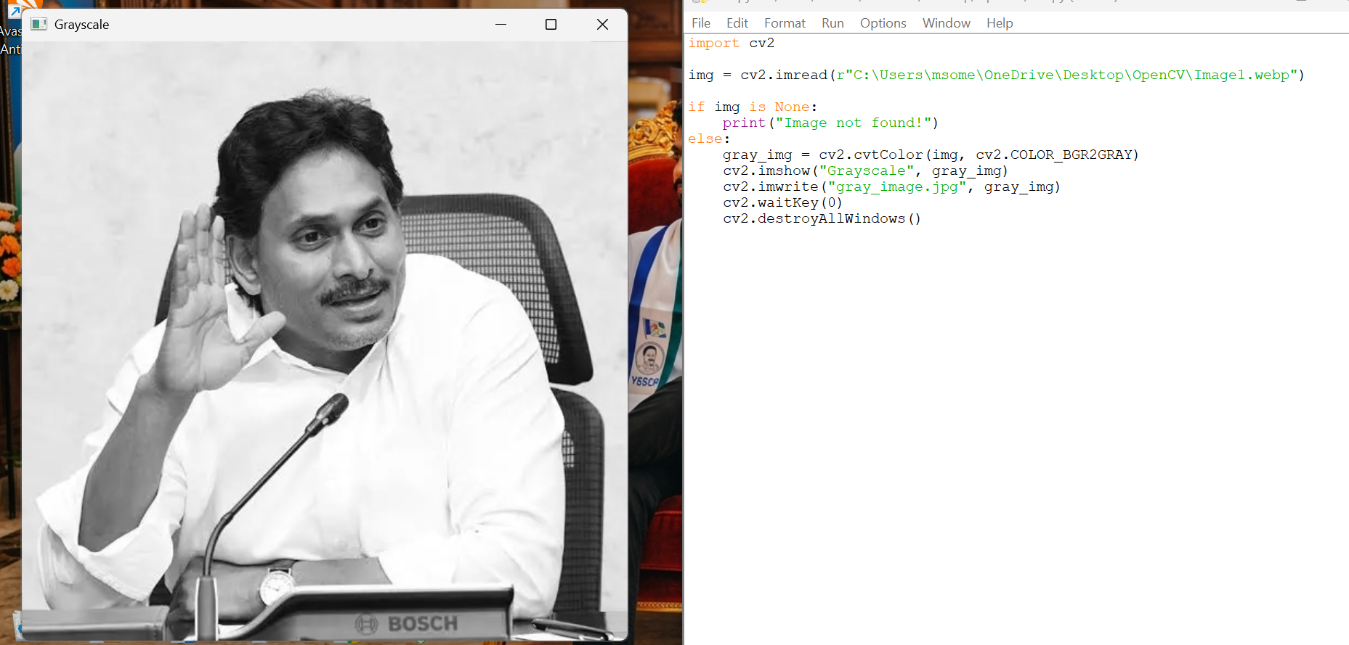

Result
The image was successfully converted into grayscale.

Experiment 2: Apply Gaussian Blur

Aim
To apply Gaussian Blur to an image using OpenCV.

Procedure
- Import OpenCV.
- Read the input image.
- Apply Gaussian Blur.
- Display the original and blurred images.
- Close all windows.

Algorithm
- Start
- Import required libraries
- Read the image
- Perform the required operation
- Display the output
- Stop

Input


Output
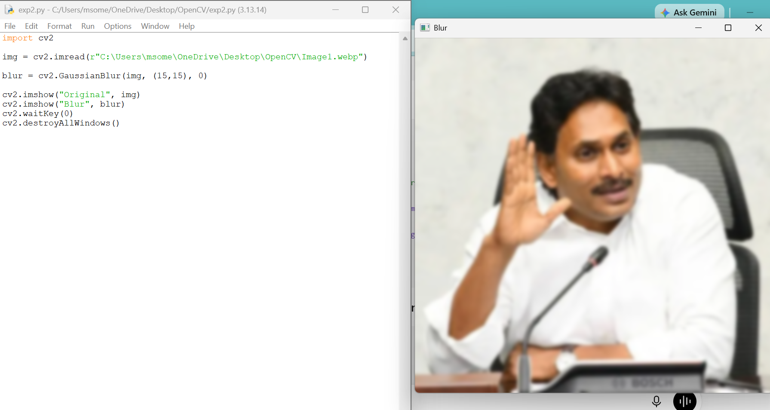

Result
The Gaussian Blur filter was successfully applied.

Experiment 3: Detect Edges Using the Canny Function

Aim
To detect the edges of an image using the Canny edge detection method.

Procedure
- Import OpenCV.
- Read the input image.
- Convert it to grayscale.
- Apply the Canny function.
- Display the edge image.
- Close all windows.

Algorithm
- Start
- Import required libraries
- Read the image
- Perform the required operation
- Display the output
- Stop

Input


Output
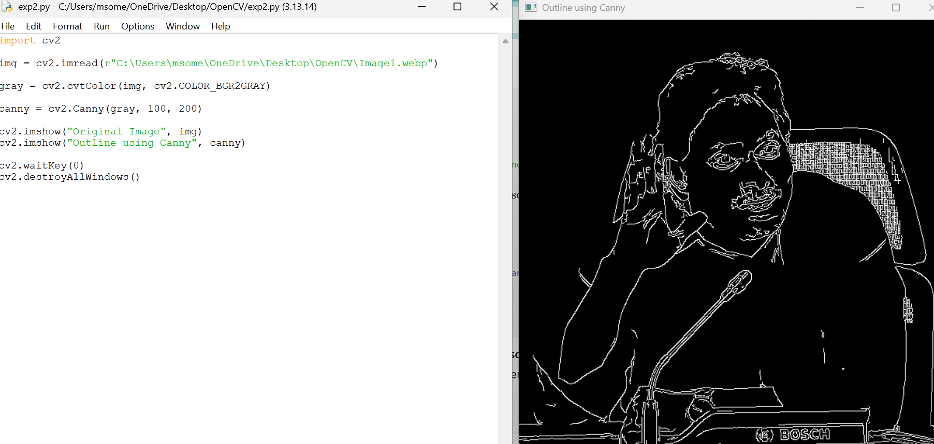

Result
The edges of the image were successfully detected.

Experiment 4: Perform Image Dilation

Aim
To perform image dilation using OpenCV.

Procedure
- Import OpenCV and NumPy.
- Read the input image.
- Create a kernel.
- Apply dilation.
- Display the result.
- Close all windows.

Algorithm
- Start
- Import required libraries
- Read the image
- Perform the required operation
- Display the output
- Stop

Input
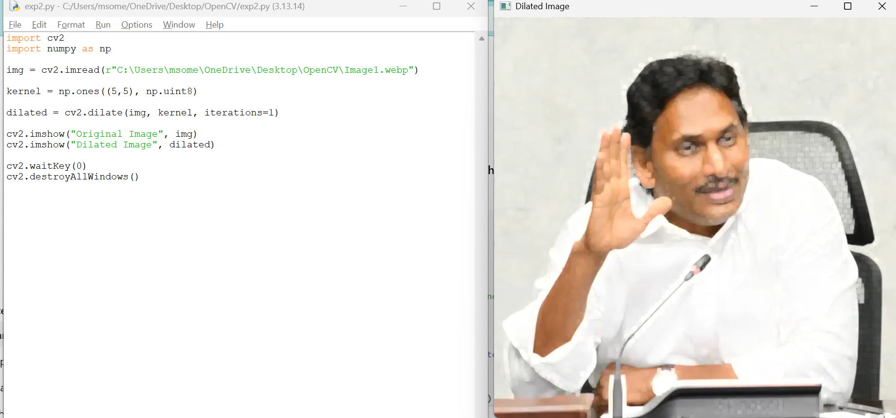

Output

Result
The image was successfully dilated.

Experiment 5: Perform Image Erosion

Aim
To perform image erosion using OpenCV.

Procedure
- Import OpenCV and NumPy.
- Read the input image.
- Create a kernel.
- Apply erosion.
- Display the result.
- Close all windows.

Algorithm
- Start
- Import required libraries
- Read the image
- Perform the required operation
- Display the output
- Stop

Input


Output
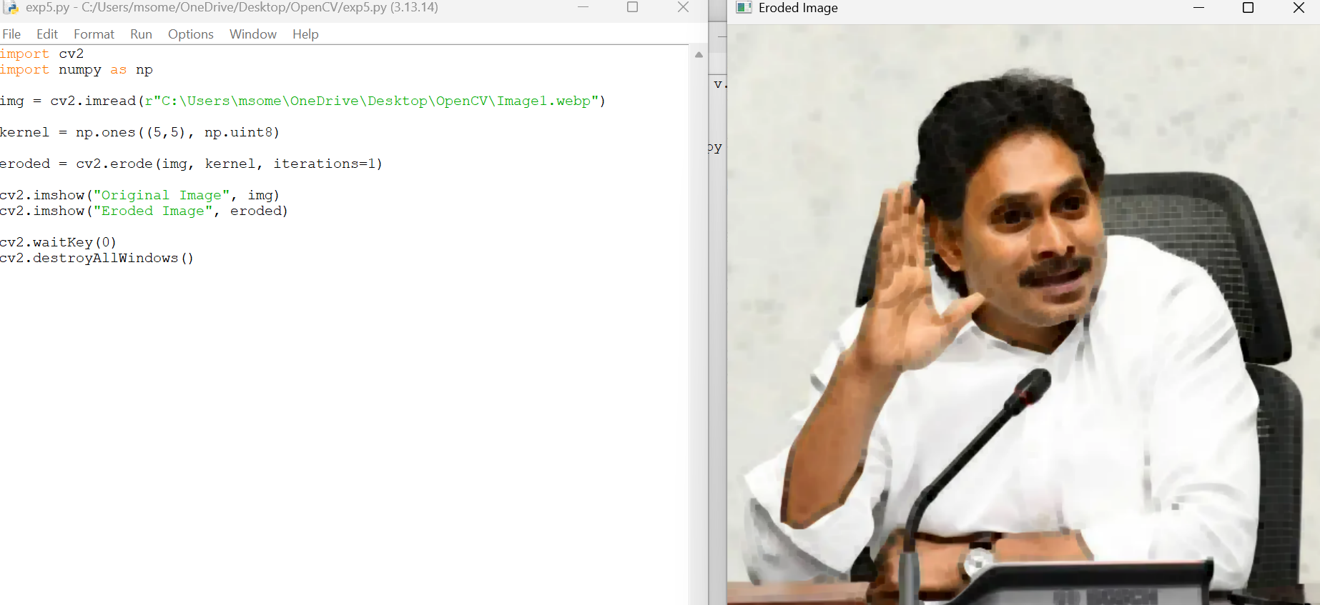

Result
The image was successfully eroded.

